**ASSIGNMENT 2**

**It’s the commercial that launched 1,000 memes. In 2019, exercise bike maker Peloton released a holiday commercial showing a husband gifting his thin wife with the stationary exercise bicycle. The Internet reacted swiftly and they were not happy. “Message received: Ladies, exercise harder/be thinner for your man and then thank him for it,” one user wrote. But was it all bad for Peloton?**

**Investigate consumer reactions surrounding Peloton's 2019 holiday commercial with the help of Google Trends, Twitonomy, LIWC, and Facebook Audience Insights. Considering the marketing value created with its subsequent fallout, was the commercial positive or negative for the brand?**

**Substantiate your opinion with a fact-base earned from the tools you use and collect your thoughts, data points, and visualizations (including screenshots) in the attached document. Post your response here before class on Week 6 [20 points]**

Peloton released their Christmas ad “A gift like no other” on 12th November, 2019 which depicts a wife being gifted a peloton exercise bicycle worth ~2200 USD. She then proceeds to vlog her journey of using the bike for a year and shows her husband towards the end how impactful the bike was for her. This ad was then followed by severe backlash with the ad being called sexist and dystopian, parodies were created and Peloton’s stocks saw a drop in their share prices by 15% over the course of two days dropping their market value by ~2.5 billion USD. To understand the overall impact of this ad on Peloton, let’s deep dive into the ad and correspond it with various trends across multiple social media platforms.

1. **Google Trends and News articles**

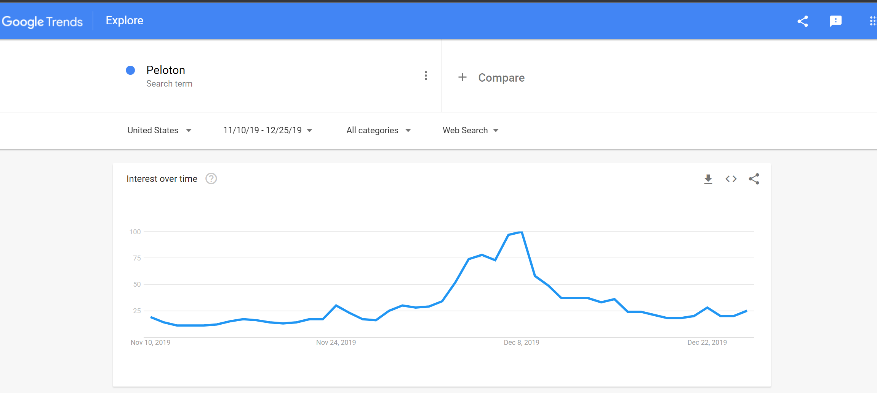

From the above it can be seen that while the ad was released on Nov 12th on Twitter and TV, Peloton didn’t see much of a rise in its interest until Dec 2nd, 2019 where it saw a sudden increase in searches with the highest tip on Dec 8th.

A look at the related popular topics and related top queries, the following can be seen (source: Google Trends for the above):

|  |  |  |  |
| --- | --- | --- | --- |
| **TOP Topics** |  | **TOP Queries** |  |
| Peloton | 100 | peloton bike | 100 |
| Peloton Interactive | 73 | peloton commercial | 66 |
| Bicycle | 24 | peloton ad | 42 |
| Television advertisement | 17 | peloton stock | 14 |
| Advertising | 10 | peloton bike ad | 13 |
| Treadmill | 3 | peloton price | 11 |
| Controversy | 2 | treadmill | 10 |
| Gin | 2 | peloton treadmill | 10 |
| Parody | 1 | peloton cost | 9 |
| Stationary bicycle | 1 | peloton black friday | 8 |
| Ryan Reynolds | 1 | peloton gin | 7 |
| NordicTrack | 1 | peloton girl | 7 |
| Aviation American Gin | 1 | peloton actress | 7 |
| Monica Ruiz | 1 | peloton wife | 6 |
| Echelon | 1 | peloton shoes | 6 |
| Sexism | <1 | peloton controversy | 6 |
| Jill de Jong | <1 | peleton | 6 |
| Viral video | <1 | peloton app | 5 |
| Parody advertisement | <1 | how much is peloton | 5 |
|  |  | peloton sale | 5 |
|  |  | what is peloton | 5 |
|  |  | peloton bike commercial | 4 |
|  |  | peloton ryan reynolds | 4 |
|  |  | peloton tread | 4 |
|  |  | peloton bike cost | 4 |

In order to pinpoint the cause for the increase from Dec 2, 2019 onwards, comparing the above trend line with the following topics:

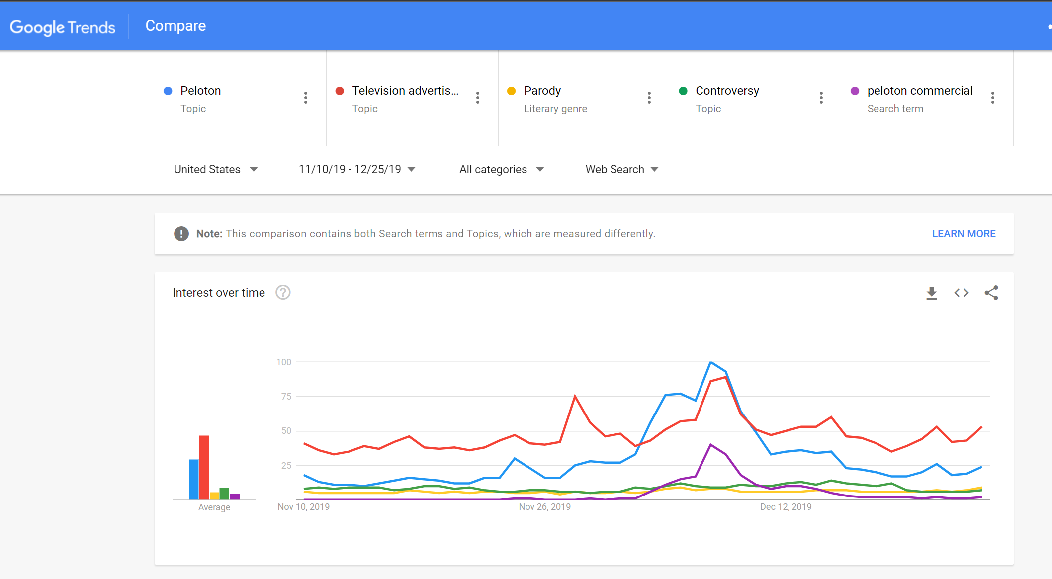

It can be seen that Peloton saw an increase in their search following a course similar to the commercial, controversy and parody.

A quick look at the term parody itself to identify which parody might have led to the increase in google trends for Peloton:

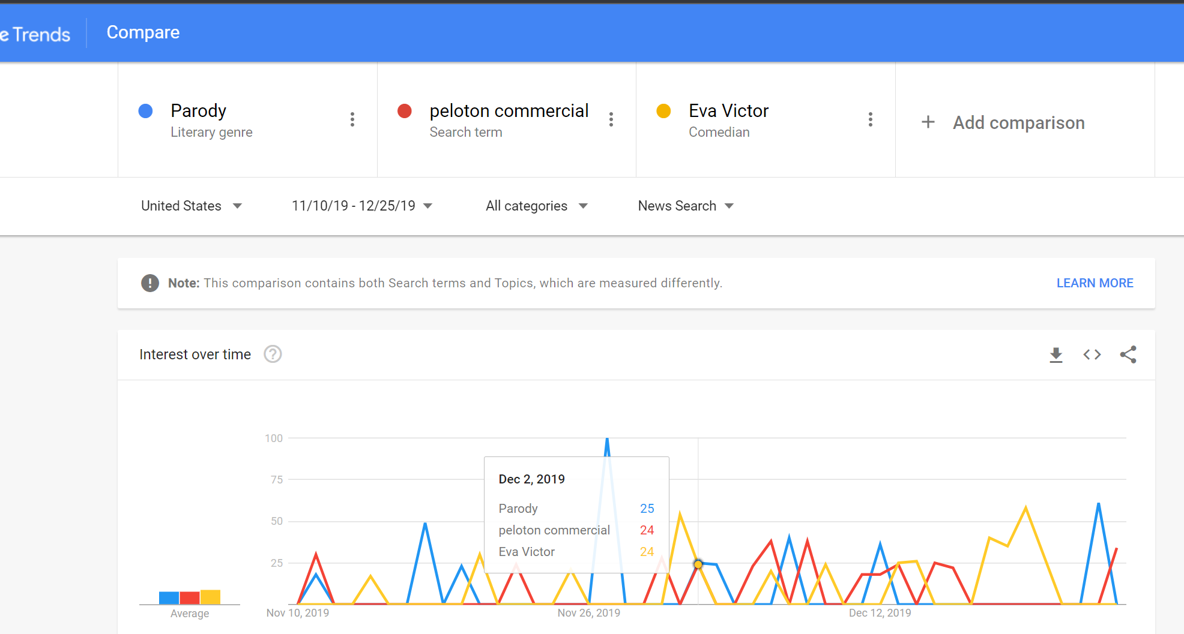

Based on this it can be assumed that Eva Victor’s parody of the Peloton Christmas ad led to an increase in the awareness of Peloton’s commercial as they all have a similar course when the video was dropped on Twitter.

Looking at the video posted by Eva Victor on Twitter, it had gone viral and has garnered approximately 4.3 million views till date which is much higher than Peloton’s ad on Twitter which has ~894.3K views till date. While Eva’s video is a satire on the supposed sexism in the Peloton commercial, skimming through the comments shows a more positive support for the product, however with the video becoming viral, the comments on Peloton’s post that day show a bleaker image as a result of the parody.

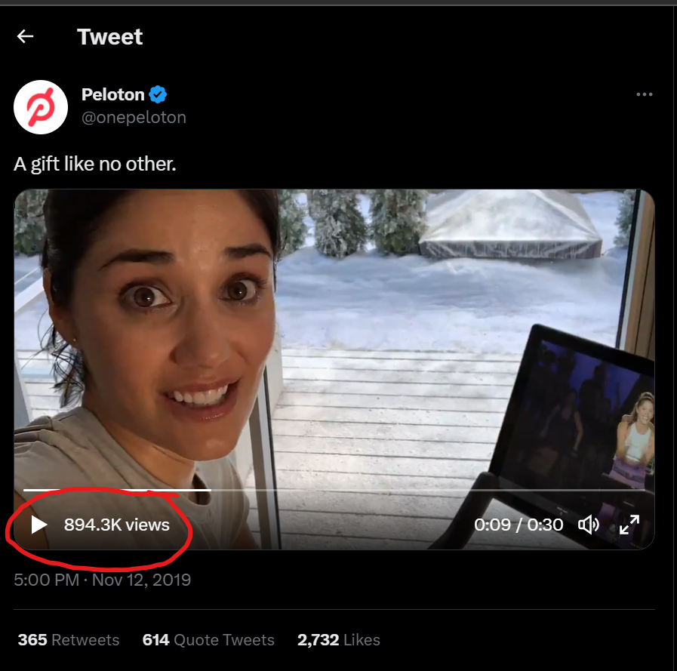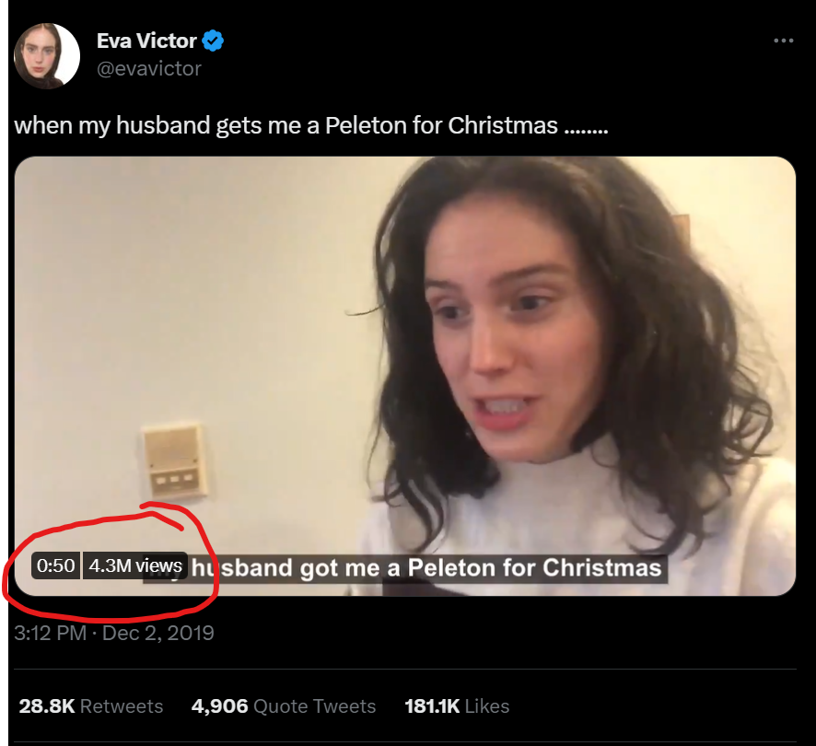

The reason for it going viral also makes sense while looking at Twitter sentiment analysis for Eva Victor who is widely popular across the platform (data for this case was not available, so just looked at her profile in general at Social Bearing)

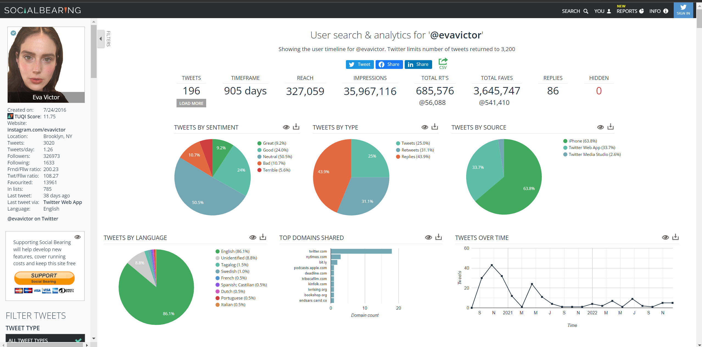

This story is then picked up by news outlets like the New York Times that gives an image of a severe negative response to the advertisement and comparing it to the Black Mirror episode: 15 Million Merits – an episode about exercise bikes being used by society to earn their keep – based off one of the most popular tweets regarding this conversation by Jess Dweck and the fact that the actress looked worried in the popularly shared screenshot.

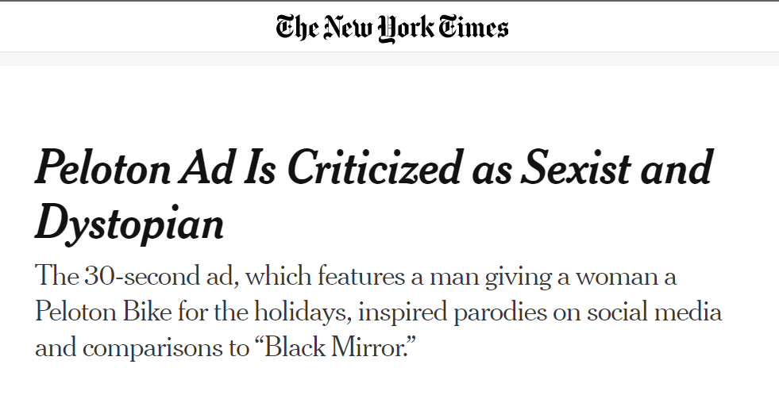

It can also be seen that Peloton commercial’s trend increases along with New York Times on Dec 3rd, 2019.

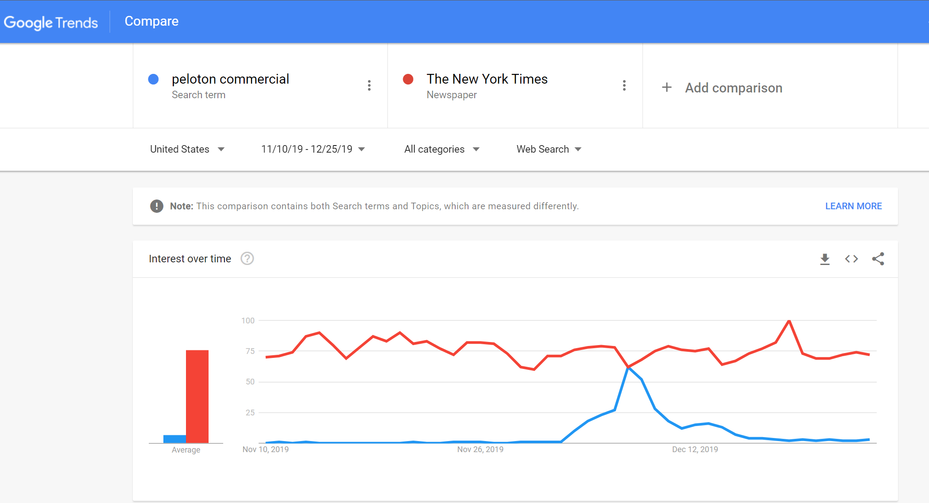

Another issue highlighted by many in the comments is how there is no transformation shown through the ad. The actress was thin from the beginning to the end of the advertisement. This might be because of how fitness and Peloton are closely related and exercise is closely related to weight loss rather than just staying healthy.

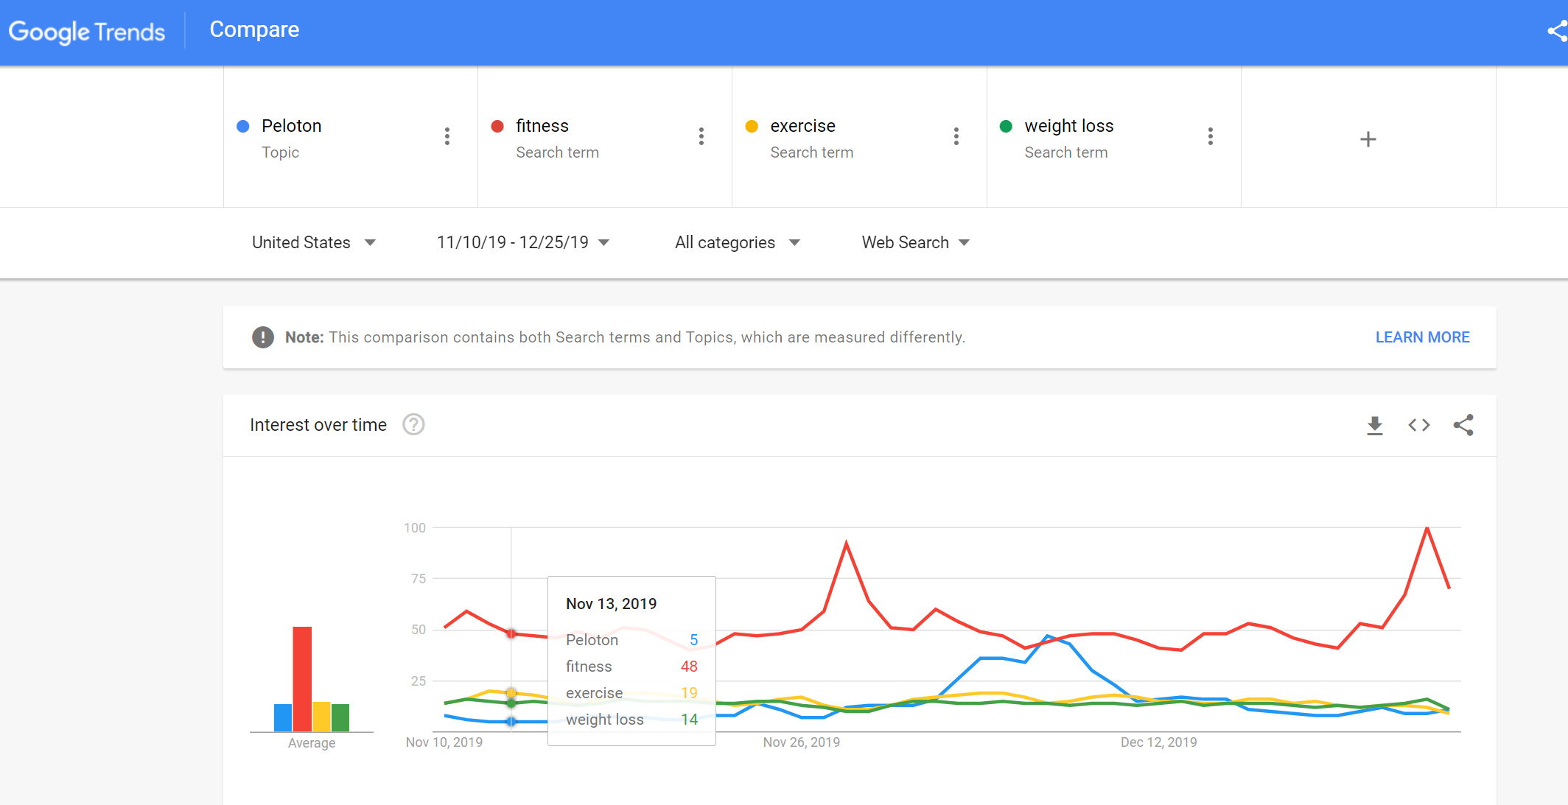

Post this, the Peloton share value dropped drastically by ~9% and it can be attributed to the viral parody video as it happens the very next day which is Dec 3rd.

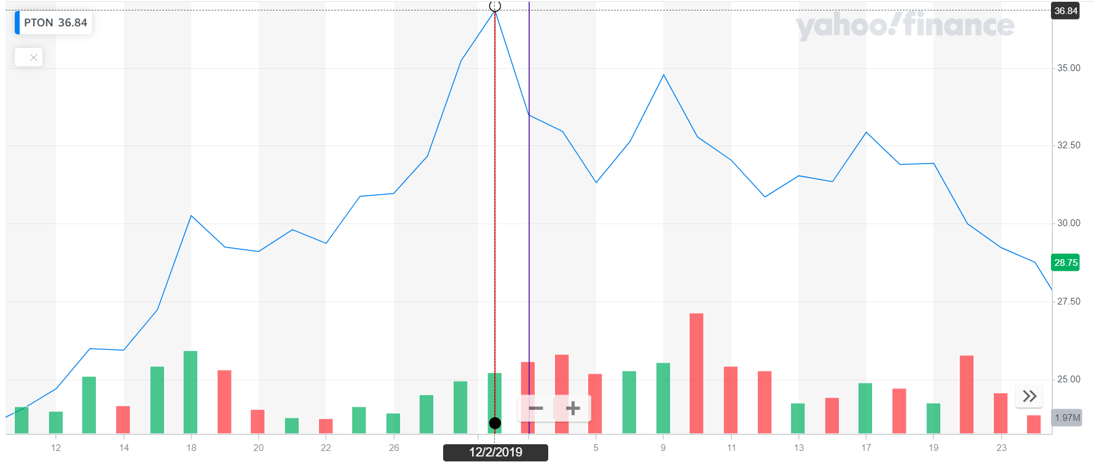

Their share prices continue to drop until Dec 6th, 2019, when there’s a sudden increase in the share market value. An analysis of this with the search terms marked as ‘breaking’ by Google trends during this period, the following trend occurs:

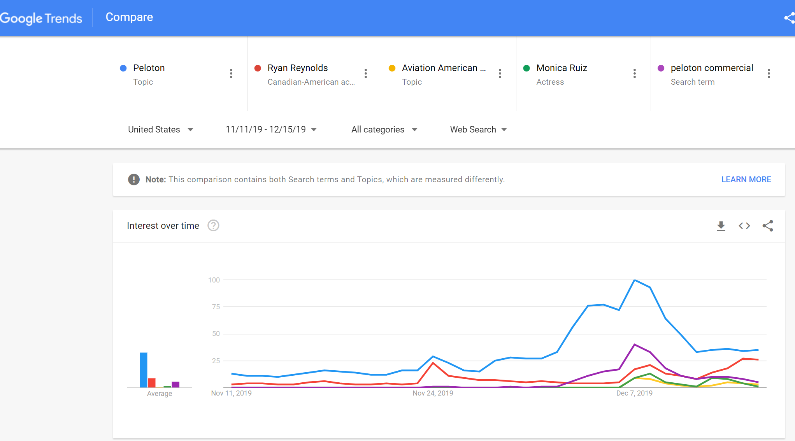

It can be seen that Peloton, Ryan Reynolds, Aviation Gin, Monica Ruiz and peloton commercial are all following a similar trend especially between Dec 6th – Dec 8th. The reason for this is that Ryan Reynolds, a popular actor and owner of Aviation Gin released an ad for the company featuring the actress (Monica Ruiz) who also acted in the Peloton commercial; as a response to the Peloton ad in a humorous way. This move was widely well received and considered a genius marketing strategy while also increasing the awareness of Peloton as a company. This particular ad had a whopping total of 10.7 million views and 251.4K likes while also pointing to the Peloton bike cheekily. The overall sentiment under this tweet hails Ryan Reynolds for turning around the situation especially for the actress in the commercial.

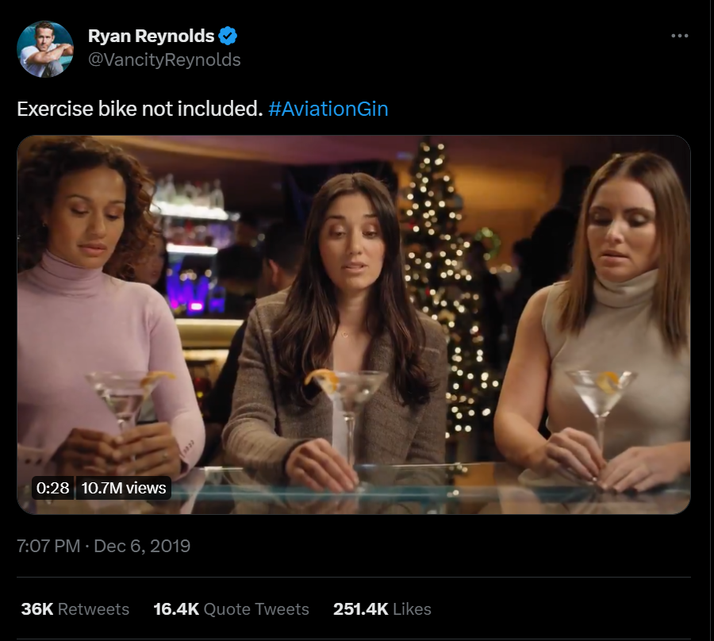

This was further picked by the Today News explaining this entire journey thereby keeping Peloton actively in the news and increasing their outreach even more. This video currently has ~2 million views till date.



1. **Timeline**

The above can be summarized below:

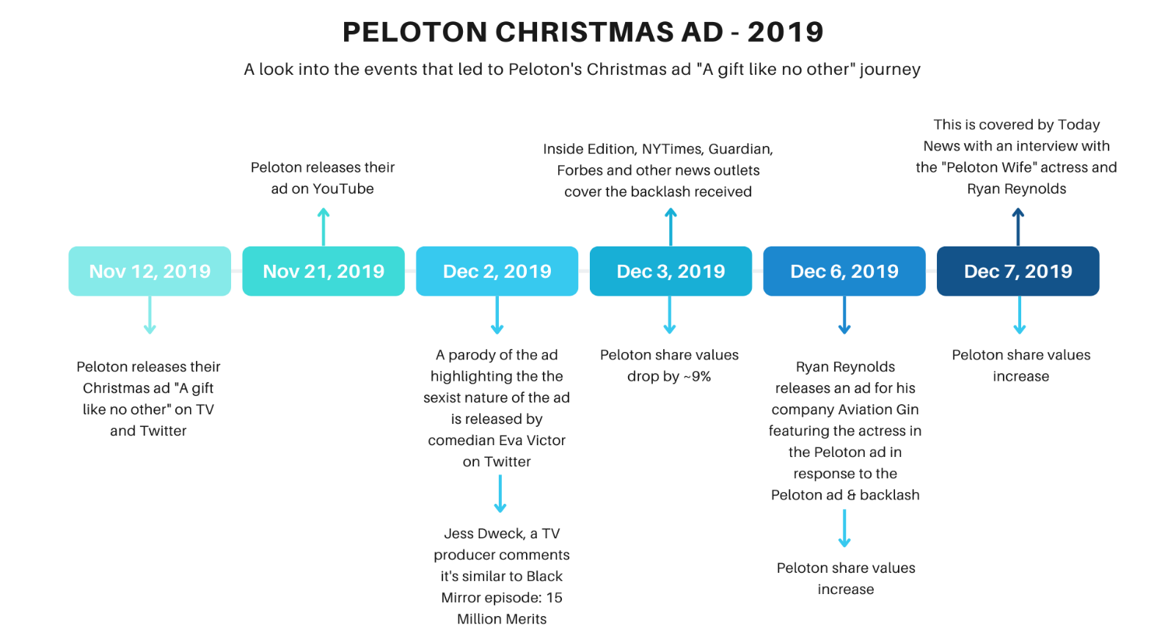

Based on these facts, it can be seen that while a misconstrued parody led to giant downfall in Peloton’s market value over the course of 2 days, bad press can also lead to good press like in this case, piggy banking off the gin advertisement helped increase Peloton’s brand reach drastically. While their revenue may have dropped that quarter, it did increase steadily over the next quarter.

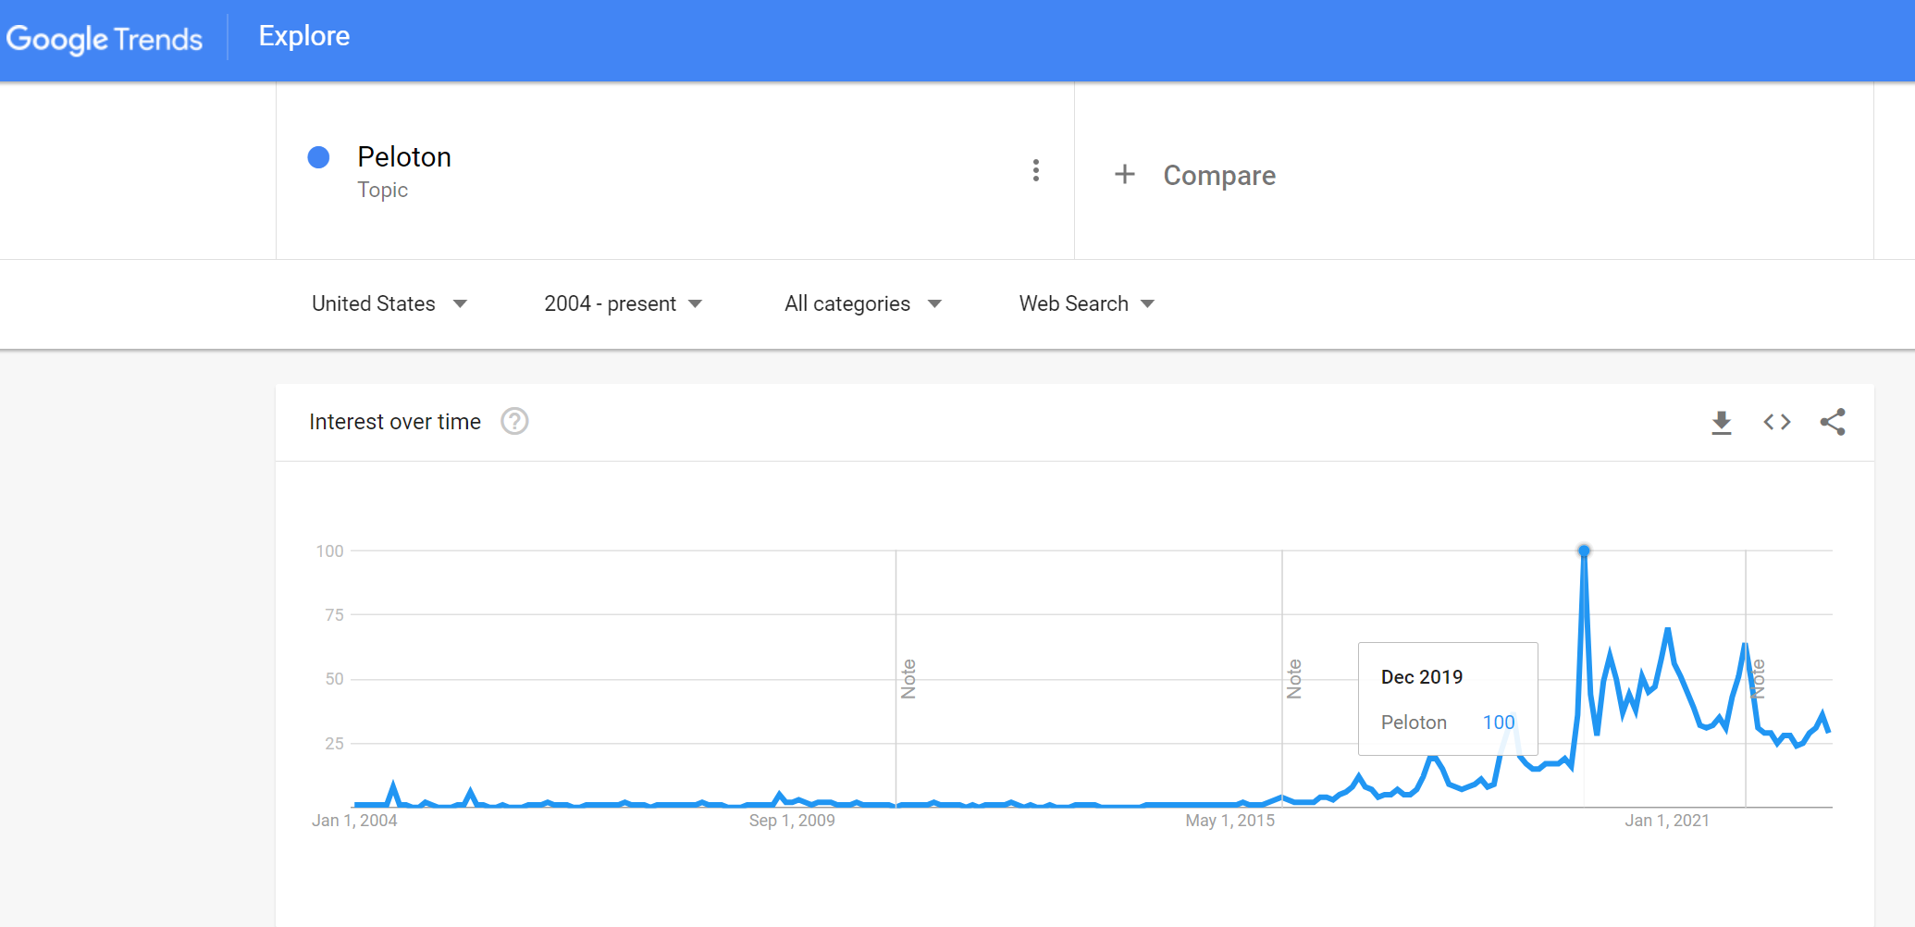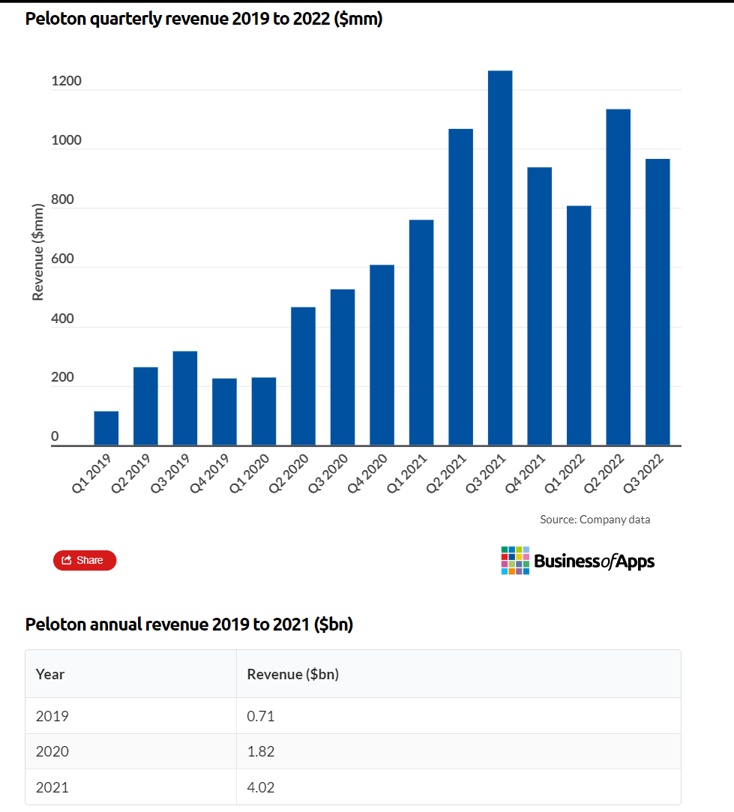

In fact, post this their market shares did increase for a while probably due to the pandemic but it was no longer affected by the advertisement and the sentiment around it.

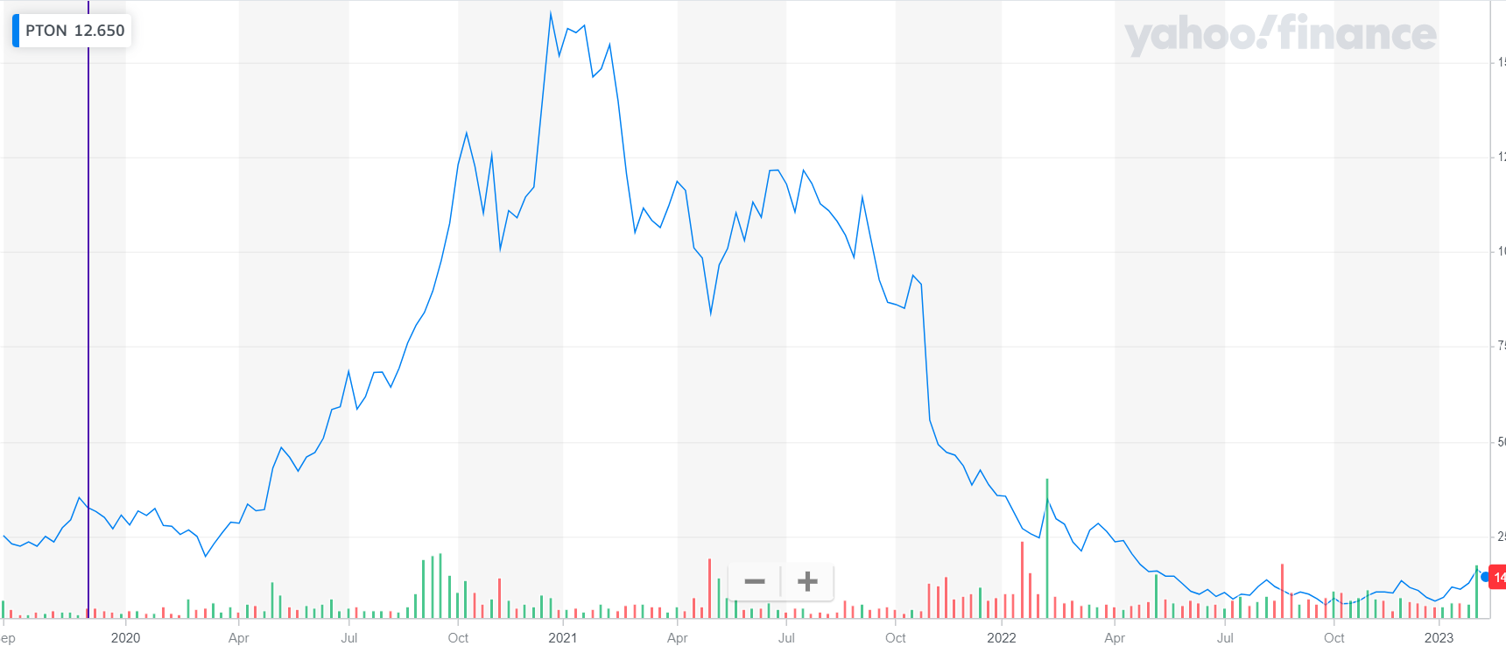

1. **Twitter sentiment**

While the overall Twitter sentiment data is not available for that particular time period, a look at these topics show that the overall sentiment is not bad, it’s somewhat neutral or good. So this just seemed like a hiccup in the overall run.

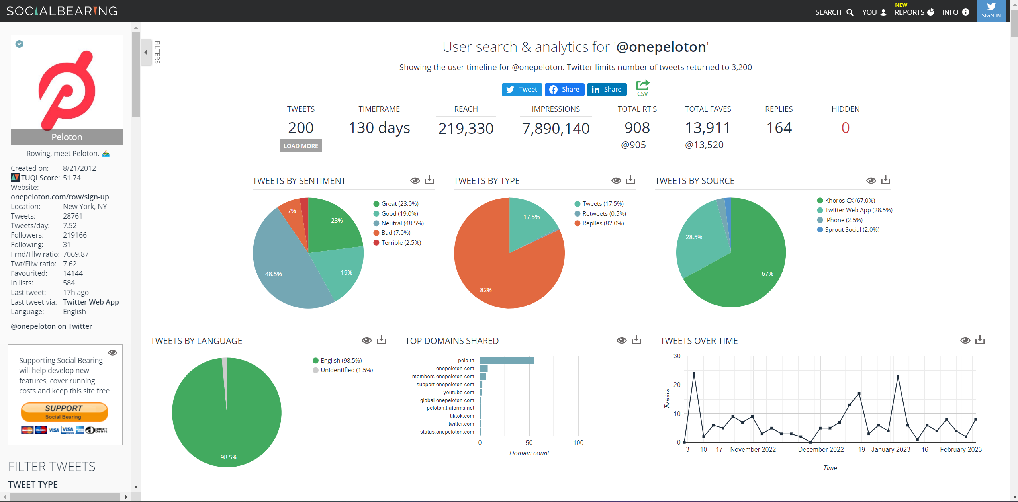

1. **References**

* <https://www.youtube.com/watch?v=Q6emtEW_QeY&t=3s>
* <https://twitter.com/evavictor/status/1201610153549848580?ref_src=twsrc%5Etfw%7Ctwcamp%5Etweetembed%7Ctwterm%5E1201610153549848580%7Ctwgr%5E67c9e8dee487561842beb215a3e70294838a168b%7Ctwcon%5Es1_&ref_url=https%3A%2F%2Fwww.yahoo.com%2Fnow%2Fwoman-goes-viral-on-twitter-for-spoof-of-peloton-ad-234234482.html>
* <https://www.clubindustry.com/insights-resources/peloton-s-ad-controversy-has-been-overshadowed-by-declining-stock-prices#:~:text=The%20ad%2C%20published%20to%20YouTube,and%20its%20virtual%20workout%20content>.
* <https://www.nytimes.com/2019/12/03/business/peloton-bike-ad-stock.html>
* <https://twitter.com/onepeloton/status/1194389524203343873>
* <https://twitter.com/vancityreynolds/status/1203118775815622664?ref_src=twsrc%5Etfw>
* <https://finance.yahoo.com/>
* <https://www.businessofapps.com/data/peloton-statistics/>